BACKER HOTWATT · 16A ELECTRONICS AVENUE · DANVERS, MA. 01923-1011



June 2, 2021

RE: California Proposition 65

California Proposition 65 refers to legislation that requires businesses to provide warnings to Californians about significant exposures to chemicals that cause cancer, birth defects or other reproductive harm. These chemicals can be in the products that Californians purchase, in their homes or workplaces, or that are released into the environment. California is required to publish a list of chemicals, updated at least yearly, known to cause cancer, birth defects or other reproductive harm. The latest list was published on March 19, 2021 and can be found at the following website [www.oehha.ca.gov/proposition-65/proposition-65-list.](http://www.oehha.ca.gov/proposition-65/proposition-65-list) .

Backer Hotwatt evaluates the updated chemical list annually. Based on our business operations, product mix and to the best of our knowledge of all raw materials and components used in the manufacturing of our products, we **cannot** declare that our products are in full compliance with the current list of chemicals identified by the State of California Environmental protection Agency under the statute of Proposition 65. Many of the resistance wires, sheaths and lead conductors used in the heater design are alloy materials which may contain Nickel and Nickel is present on the current list. In addition, many of the wire insulating materials contain Teflon (TFE), Silicone and Neoprene. Some insulations containing silicone, can give off trace amounts of formaldehyde gas under extreme fire or burning conditions. Formaldehyde is included on the current list. Neoprene is also an insulator used on some lead wires and is produced using Chloroprene, also on the list. These material types of conductors and insulators are used in the design of our products to meet or exceed all applicable agency and customer specifications.

Backer Hotwatt continues to work with our suppliers, customers and code body agencies to design and evaluate new and improved materials and constructions. Please refer to our website, www.hotwatt.com for the latest product information and innovative solutions.

Sincerely,

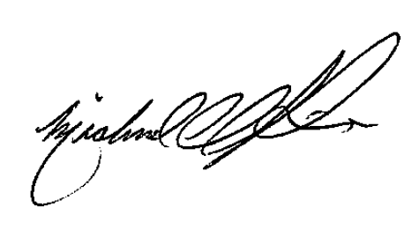

Michael Parisi

Quality Manager

TELEPHONE 978-777-0070 FAX 978-774-2409 [www.hotwatt.com](http://www.hotwatt.com)